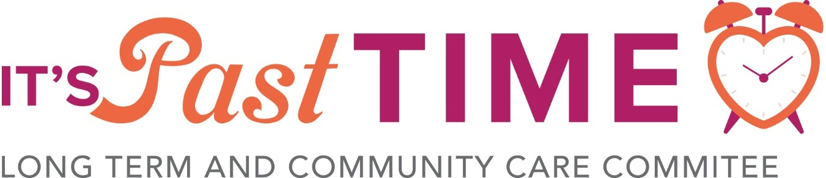

First Day of Bargaining Goes Well

Long Term Care – Bargaining Update

August 18, 2025

Bargaining

Lead table bargaining, headed by St. Vincent’s Guest House, began on August 14th with our first exchange of proposals. The bargaining team discussed the priority items affecting our sector and tabled wage increases for all classifications that would, if agreed to, bring those trailing behind the rest of Atlantic Canada up. In addition to this position, we will be focusing our messaging around “Flat 5,” which echoes our proposals for $5 increases for every classification. We have four further bargaining dates scheduled in September.

This week, we asked members at St. Vincent’s Guest House to record short videos of themselves offering encouraging words to the bargaining committee that we could share to social media as one longer message of support and spread the word that bargaining has begun—with the full and earnest support of the membership. If you want to send a message to the lead table too, record a quick video in selfie mode on your phone and upload it to: https://www.dropbox.com/request/WSZnOjGo7nvqHSsr8xGx

Committee Actions

At the beginning of August, we also held two strike preparation days which provided education, support, and a chance for members to ask questions about what potential job action could look like in the future. While we don’t want to go on strike and hope bargaining continues smoothly, the committee believes it’s important for the sector to be prepared, so we will continue to provide education and further communication to keep all members in the loop.

Please keep an eye on your email or our website for further updates about bargaining, the work of the committee, or sector-wide events.

If you have any questions, please email us at cupensltcc@gmail.com.
In solidarity,
Kim Loppie, LTCCSCC Communications Officer

